Question 1:

Code:

#include <iostream>

using namespace std;

int * input();

int main()

{

int *ptr1, *ptr2;

int arr[3][3];

int sm = 0;

ptr1 = input();

ptr2 = input();

for (int i = 0;i < 3;i++)

{

for (int k = 0;k < 3;k++)

{

sm = 0;

for (int j = 0;j < 3;j++)

{

sm += (*(ptr1 + (i * 3) + j))*(*(ptr2 + (j * 3) + k));

}

arr[i][k] = sm;

}

}

for (int i = 0;i < 3;i++)

{

for (int j = 0;j < 3;j++)

cout << arr[i][j] << " ";

cout << endl;

}

system("pause>0");

return 0;

}

int * input()

{

int *ptr;

cout << "Enter a 3 x 3 Matrix:\n ";

ptr = new int[9];

for (int i = 0;i < 9;i++)

cin >> *(ptr + i);

return ptr;

}

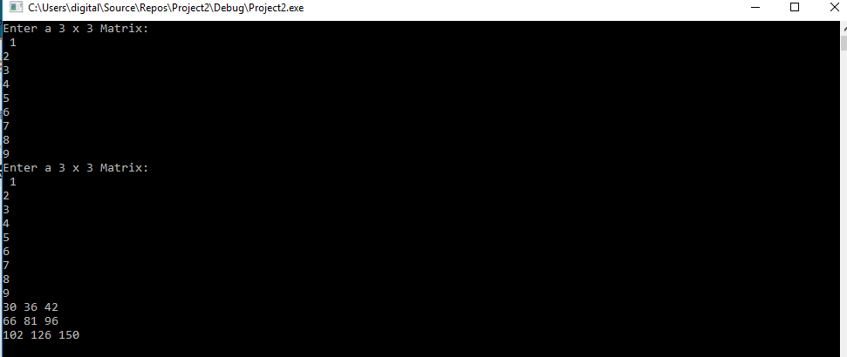

Question 5:

Code:

#include <iostream>

#include<cstdlib>

using namespace std;

int diagonal(int* (ptr), int col);

int main()

{

srand(time_t(NULL));

int arr[3][3] = { 0 };

int *ptr = &arr[0][0];

for (int i = 0; i < 3; i++)

{

for (int j = 0; j < 3; j++)

{

*(ptr + i * 3 + j) = rand() % 16;

}

}

cout << "The is the 2D 3x3 Array generated by the Computer" << endl;

for (int i = 0; i < 3; i++)

{

for (int j = 0; j < 3; j++)

{

cout << *(ptr + i * 3 + j) << "\t";

}

cout << endl;

}

cout << "Diagonals are: ";

for (int i = 0; i < 3; i++)

{

cout << diagonal(ptr, i) << " , ";

}

system("pause>0");

return 0;

}

int diagonal(int* (ptr), int col)

{

int x = 0;

for (int i = 0; i <= col; i++)

{

x = *(ptr + i * 3 + i);

}

return x;

}

